In the event of my death . . .

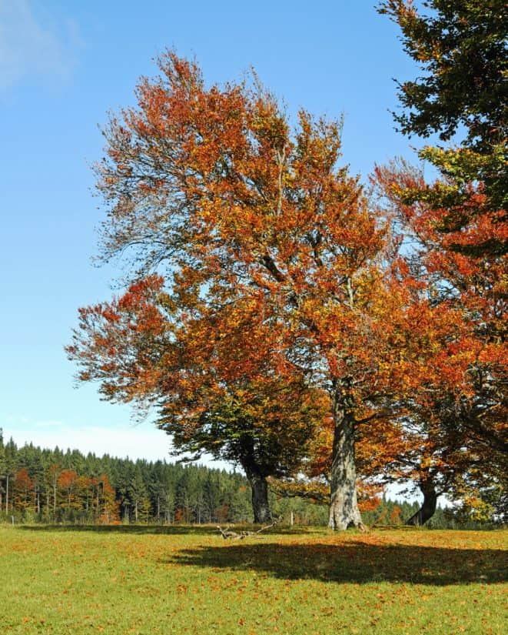
Information you need to know

My Name: _________________________________________________________________
Name I like to be known as: ____________________________________________________
Date of Birth: _______________________________________________________________
Place of Birth: _______________________________________________________________
Maiden Name (if applicable) : __________________________________________________
Date form completed: ________________________________________________________

Next of Kin – Name, address and contact number

Other family members – Name, relationship (daughter/son) contact number

Name of GP and Practice

Solicitor – name and contact details

Accountant – name and contact details only

Bank – name and contact details only

Building society – name and contact details only

Dentist – name and contact details

Organ Donations: detail your wishes
Heart / Lungs / Cornea / Pancreas / Small Bowel / Tissue / Bone / Kidneys / Liver

Keep legal documents together in one place, ensure someone you trust knows the location of documents:
Birth Certificate |  | National Insurance Number
Marriage Certificate |  | Benefits information
Divorce documents |  | Social Media Accounts/passwords
Will |  | Health Insurance documents
House Deeds/Mortgage Information |  | Bank/Building society books / accounts
Passport |  | Stocks/shares Investment Information
Utility providers – gas / internet etc |  | State Pension Details
House / Car Insurance Company |  | Private Pension Details
Car Registration Documents |  | Funeral/Life Insurance Information

Employment Details
Name, address and contact number of employer or business partners:

Position/Job title:

Pets – what are you wishes with regards to pets, who would you like to look after them

Funeral Requests Please detail your wishes

Have you a funeral plan? Name and contact details.

My funeral will take place at: …………………………………………………………………………………….

Favourite hymns, readings, music or/and poems: ……………………………………………………

…………………………………………………………………………………………………………………………………..

………………………………………………………………………………………………………………………………….

I would like donations from my funeral to go to: ……………………………………………………….

After my funeral I want to be:
Buried at the following location: …………………………………………………………

Cremated at the following location: …………………………………………………..

My ashes should then be:
Scattered at the following location: …………………………………………………….
Or
Buried at the following location ………………………………………………………..

Clubs/Societies/Friends to notify of my death – name, address and contact number

